HTML5 Elements semantics
La semàntica és l'estudi dels significats de paraules i frases en un idioma.
Elements semàntics = elements amb significat.

What are Semantic Elements?

Un element semàntic descriu clarament el seu significat tant per al navegador com per al desenvolupador.
Exemples d'elements no semàntics: <div> i <span>: no diu res sobre el seu contingut.
Exemples d'elements semàntics: <h1>, <p>, <table> i <article> - Defineix clarament el seu contingut.
Els elements semàntics HTML5 són compatibles amb tots els navegadors moderns.

In addition, you can "teach" older browsers how to handle "unknown elements". (HTML5Shiv)
http://www.htmlcinco.com/que-es-html5-shiv/

HTML Layout Elements (etiquetes estructurals)

Els llocs web solen mostrar contingut en diverses columnes (com una revista o un periòdic).
HTML5 ofereix nous elements semàntics que defineixen les diferents parts d'una pàgina web:

Many web sites contain HTML code like: <div id="nav"> <div class="header"> <div id="footer"> to indicate navigation, header, and footer.

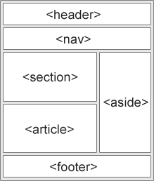

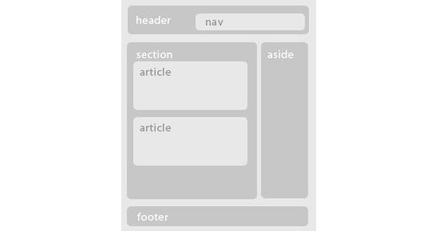

<header> | The <header> element specifies a header for a document or section.  The <header> element should be used as a container for introductory content.  You can have several <header> elements in one document.  Dentro del body ⇒ encabezado de la página.  Dentro de article, section, nav o aside ⇒ encabezado del elemento.  Usos habituales:  - logotipo  - menu general  - tıtulo (h1 -h6 )  - enlaces  - información del autor
<nav> | The <nav> element defines a set of navigation links.  Tin en compte que NO tots els enllaços d'un document han d'estar dins d'un element <nav>. L'element <nav> està dissenyat només per al bloc principal d'enllaços de navegació.
<section> | The <section> element defines a section in a document.  According to W3C's HTML5 documentation: "A section is a thematic grouping of content, typically with a heading."  A home page could normally be split into sections for introduction, content, and contact information.  Agrupa los apartados del contenido principal del documento (capítulos, cabeceras, pies, . . . ).  Normalmente empiezan por títulos (h1, h2, . . . ) ⇒ referencia al tema de la sección.  Un section puede contener a otro section ⇒ subsecciones.  section puede contener article y article puede contener section.
<article> | The <article> element specifies independent, self-contained content.  An article should make sense on its own, and it should be possible to read it independently from the rest of the web site.  Examples of where an <article> element can be used:  - Forum post  - Blog post  - Newspaper article  Este elemento debería tener principalmente un título (un header con un h1-h6) y podría tener un footer (con la fecha de publicación, el autor o cualquier otra información adicional) y un cuerpo con el detalle.  Por ejemplo, en el caso de mostrar un listado de noticias, lo que estaremos listando será un listado de elementos article.
<aside> | The <aside> element defines some content aside from the content it is placed in (like a sidebar).  The aside content should be related to the surrounding content.  Agrupa contenido (secundario) al contenido que acompaña.  Dentro de body ⇒ secundario de la página  Dentro de article o section ⇒ secundario respecto al elemento  Usos habituales:  - bloque de anuncios  - bloque de enlaces relacionados  - citas del texto
<footer> | The <footer> element specifies a footer for a document or section.  A <footer> element should contain information about its containing element.  A footer typically contains the author of the document, copyright information, links to terms of use, contact information, etc.  You may have several <footer> elements in one document.  Dentro del body ⇒ pie de la página.  Dentro de article, section, nav o aside ⇒ pie del elemento.  Usos habituales:  - autor  - dirección  - contacto  - licencia  - condiciones de uso  - Enlaces relacionados
<details>  and  <summary> | L'etiqueta <details> especifica detalls addicionals que l'usuari pot veure o ocultar a comanda.  L'etiqueta <details> es pot utilitzar per a crear un widget interactiu que l'usuari pot obrir i tancar. Es pot posar qualsevol tipus de contingut dins de l'etiqueta <details>.  El contingut d'un element <*details> no ha de ser visible llevat que s'establisca l'atribut *open.  L'etiqueta <summary> defineix un encapçalat visible per a l'element <details>. Es pot fer clic en l'encapçalat per a veure / ocultar els detalls.  Nota: L'element <summary> ha de ser el primer element fill de l'element <details>.  https://www.w3schools.com/tags/tag_details.asp  <details>  <summary>Copyright 2015-2020.</summary>  <p> - by Refsnes Data. All Rights Reserved.</p>  <p>All content and graphics on this web site are the property of the company Refsnes Data.</p>  </details>
<figure> and  <figcaption> | The <figure> tag specifies self-contained content, like illustrations, diagrams, photos, code listings, etc.  The <figcaption> element is used to add a caption for the <figure> element.  The purpose of a figure caption is to add a visual explanation to an image.  In HTML5, an image and a caption can be grouped together in a <figure> element:  <figure>  <img src="img_pulpit.jpg" alt="The Pulpit Rock" width="304" height="228">  <figcaption>Fig.1 - The Pulpit Rock, Norway.</figcaption>  </figure>
<main> | The <main> tag specifies the main content of a document.  El contingut dins de l'element <main> ha de ser exclusiu del document.  No ha de contindre cap contingut que es repetisca al llarg del document com a barres laterals, enllaços de navegació, informació de drets d'autor, logotips del lloc i formularis de cerca.  Nota: No ha d'haver-hi més d'un element <main> en un document.  L'element <main> NO ha de ser descendent d'un element <article>, <aside>, <footer>, <header> o <nav>.
<time> | The <time> tag defines a human-readable date/time.  This element can also be used to encode dates and times in a machine-readable way so that user agents can offer to add birthday reminders or scheduled events to the user's calendar, and search engines can produce smarter search results.  How to define a time and a date:  <p>We open at <time>10:00</time> every morning.</p>  <p>I have a date on <time datetime="2019-02-14 20:00">Valentine’s day</time>.</p>

Nesting <article> in <section> or Vice Versa?

L'element <article> especifica contingut autònom i independent.

L'element <section> defineix la secció en un document.

Podem utilitzar les definicions per a decidir com relacionar aquests elements? No podem!
Llavors, en Internet, trobarà pàgines HTML amb elements <section> que contenen elements <article> i elements <article> que contenen elements <sections>.
També trobarà pàgines amb elements <section> que contenen elements <section> i elements <article> que contenen elements <article>.

Example for a newspaper: The sport articles in the sport section, may have a technical section in each article.

Examples of HTML5 Structures:

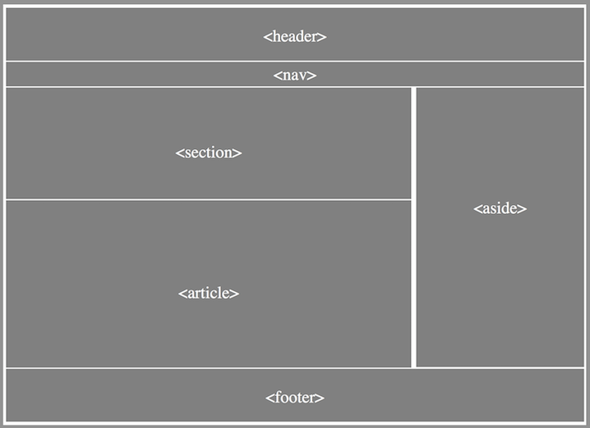

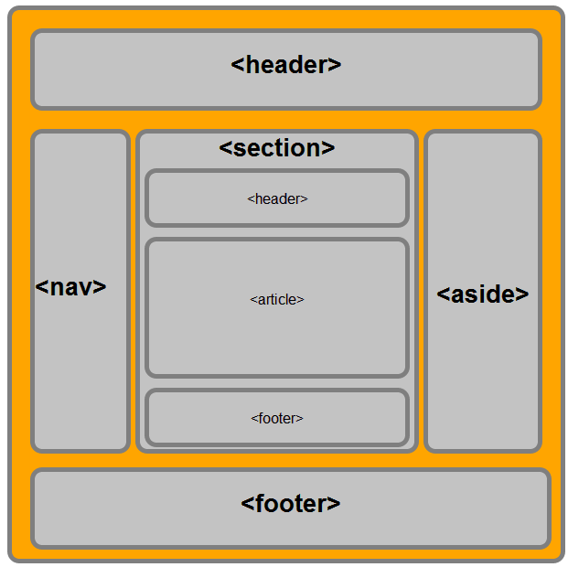
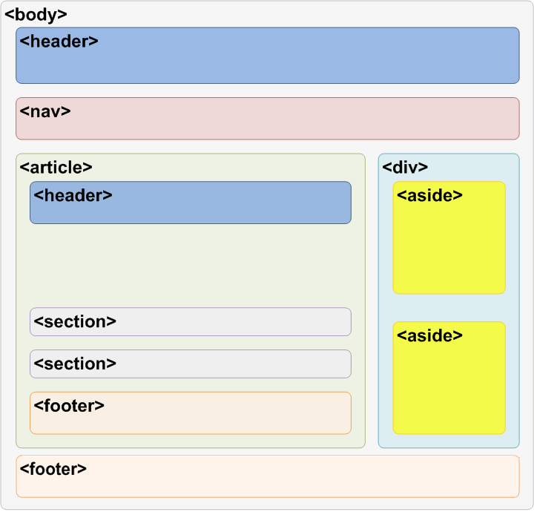

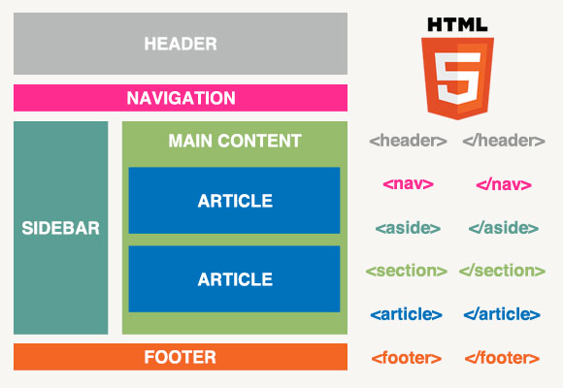

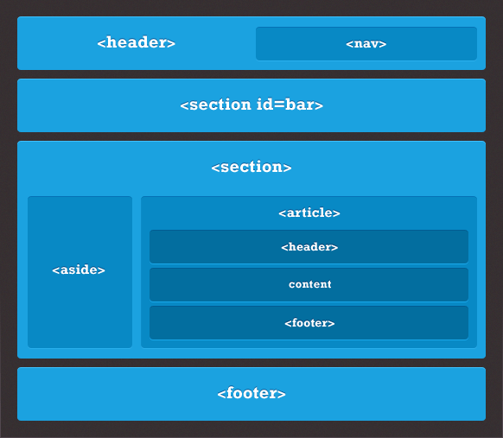

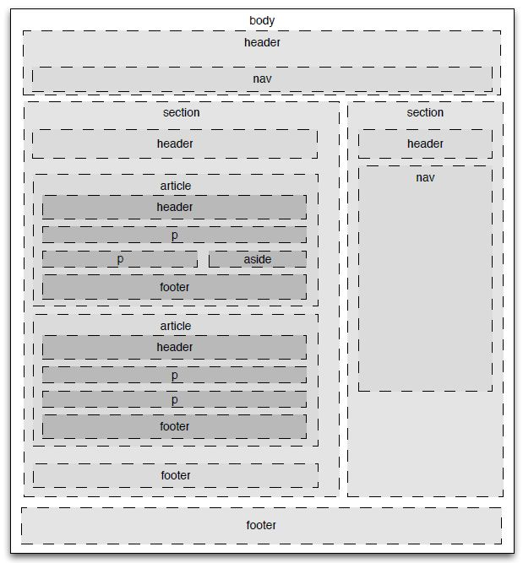

Imagina que eres un professor de llenguatge de marques.
Si eres un alumne seleccionat, prepara una classe explicant les activitats assignades.

Students | Exercises | Exposition
Substitute () | 1,2,3, 4 | 8th October

Do the following exercises:

Completa els següents codis HTML amb etiquetes semàntiques.

Recorda comprovar els teus exercicis amb: HTML Validator
https://validator.w3.org/#validate_by_input

Exercise 1

<!DOCTYPE html>
<html lang="en">
<head>
<title>Exercise 1</title>
</head>
<body>
<section>
<header><h2>WWF</h2></header>
<p>The World Wide Fund for Nature (WWF) is an international organization working on issues regarding the conservation, research and restoration of the environment, formerly named the World Wildlife Fund. WWF was founded in 1961.</p>
</section>
<section>
<header><h2>WWF's Panda symbol</h2></header>
<p>The Panda has become the symbol of WWF. The well-known panda logo of WWF originated from a panda named Chi Chi that was transferred from the Beijing Zoo to the London Zoo in the same year of the establishment of WWF.</p>
</section>
</body>
</html>

Exercise 2
<!DOCTYPE html>
<html lang="en">

<head>
<title>Exercise 2</title>
</head>

<body>
<section>
<header>
<h1>What Does WWF Do?</h1>
</header>
<p>WWF's mission is to stop the degradation of our planet's natural environment, and build a future in which
humans live in harmony with nature.</p>
</section>
<footer>
<p>Posted by: Hege Refsnes</p>
<p>Contact information: <a href="mailto:someone@example.com">
someone@example.com</a>.</p>
</footer>
</body>

</html>

Exercise 3

<!DOCTYPE html>
<html lang="en">

<head>
<title>Exercise 3</title>
</head>

<body>
<nav>
<a href="/html/">HTML</a> |
<a href="/css/">CSS</a> |
<a href="/js/">JavaScript</a> |
<a href="/jquery/">jQuery</a>
</nav>
<section>
<header>
<h1>Web Browsers</h1>
</header>
<p>Google Chrome, Firefox, and Internet Explorer are the most used browsers today.</p>
<article>
<header>
<h2>Google Chrome</h2>
</header>
<p>Google Chrome is a free, open-source web browser developed by Google, released in 2008.</p>
</article>
<article>
<h2>Internet Explorer</h2>
<p>Internet Explorer is a free web browser from Microsoft, released in 1995.</p>
</article>
<article>
<h2>Mozilla Firefox</h2>
<p>Firefox is a free, open-source web browser from Mozilla, released in 2004.</p>
</article>
</section>
<p>The Pulpit Rock is a massive cliff 604 metres (1982 feet) above Lysefjorden, opposite the Kjerag plateau, in
Forsand, Ryfylke, Norway. The top of the cliff is approximately 25 by 25 metres (82 by 82 feet) square and
almost flat, and is a famous tourist attraction in Norway.</p>
<section>

<img src="img_pulpit.jpg" alt="The Pulpit Rock" width="304" height="228">
Fig.1 - The Pulpit Rock, Norway.
<header>
<h4>Epcot Center</h4>
</header>
<p>The Epcot Center is a theme park in Disney World, Florida.</p>
<p>We open at 10:00 every morning.</p>
<p>Visit us on Christmas day!</p>
</section>

<footer>
Copyright 1999-2019.
<p> - by Refsnes Data. All Rights Reserved.</p>
<p>All content and graphics on this web site are the property of the company Refsnes Data.</p>
</footer>
</body>

</html>

Exercise 4
<!DOCTYPE html>
<html lang="en">

<head>
<title>Graduation Ceremony Summer 2019</title>
</head>

<body>

<header>
<h2>The Lawson Academy:</h2>
</header>
<nav>
<ul>
<li><a href="courses.html">Courses</a></li>
<li><a href="fees.html">Fees</a></li>
<li><a>Graduation</a></li>
</ul>
</nav>

<header>
<h1>Graduation</h1>
</header>
<nav>
<ul>
<li><a href="#ceremony">Ceremony</a></li>
<li><a href="#graduates">Graduates</a></li>
<li><a href="#awards">Awards</a></li>
</ul>
</nav>

<section>
<header>
<h2 id="ceremony">Ceremony</h2>
</header>
<p>Opening Procession</p>
<p>Speech by Valedictorian</p>
<p>Speech by Class President</p>
<p>Presentation of Diplomas</p>
<p>Closing Speech by Headmaster</p>
<article>
<header>
<h2 id="graduates">Graduates</h2>
</header>
<ul>
<li>Eileen Williams</li>
<li>Andy Maseyk</li>
<li>Blanca Sainz Garcia</li>
<li>Clara Faulkner</li>
<li>Gez Lemon</li>
<li>Eloisa Faulkner</li>
</ul>
</article>
<article>
<header>
<h2 id="awards">Awards</h2>
</header>
<ul>
<li>Clara Faulkner</li>
<li>Eloisa Faulkner</li>
<li>Blanca Sainz Garcia</li>
</ul>
</article>

</section>

<footer>2019 B.lawson</footer>

</body>

</html>

Enrique Sanz López
1º DAW

